**Jeevitha V**

**19ECR051**

1.MOTION DETECTION USING PIR SENSOR:

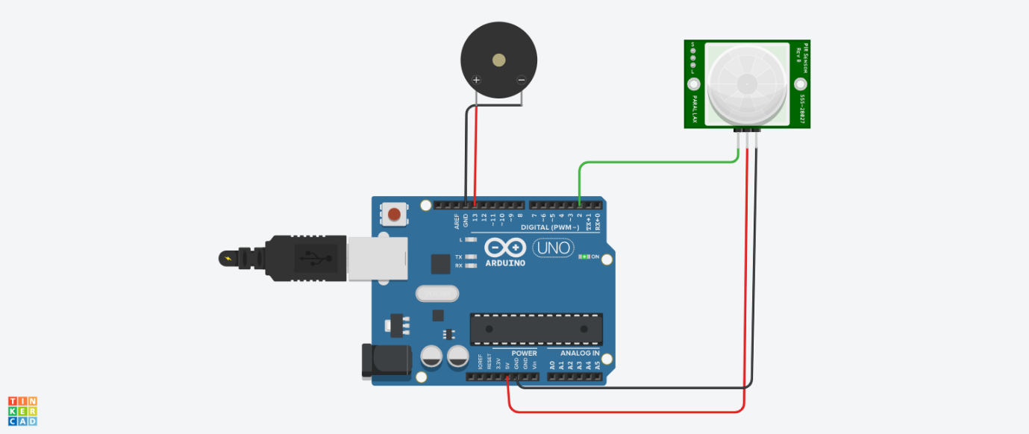

int sensorState = 0;

void setup()

{

pinMode(2, INPUT);

pinMode(13, OUTPUT);

Serial.begin(9600);

}

void loop()

{

// read the state of the sensor/digital input

sensorState = digitalRead(2);

// check if sensor pin is HIGH. if it is, set the

// LED on.

if (sensorState == HIGH) {

digitalWrite(13, HIGH);

Serial.println("Sensor activated!");

} else {

digitalWrite(13, LOW);

}

delay(10); // Delay a little bit to improve simulation performance

}

2.TEMPERATURE DETECTION USING TEMPERATURE SENSOR

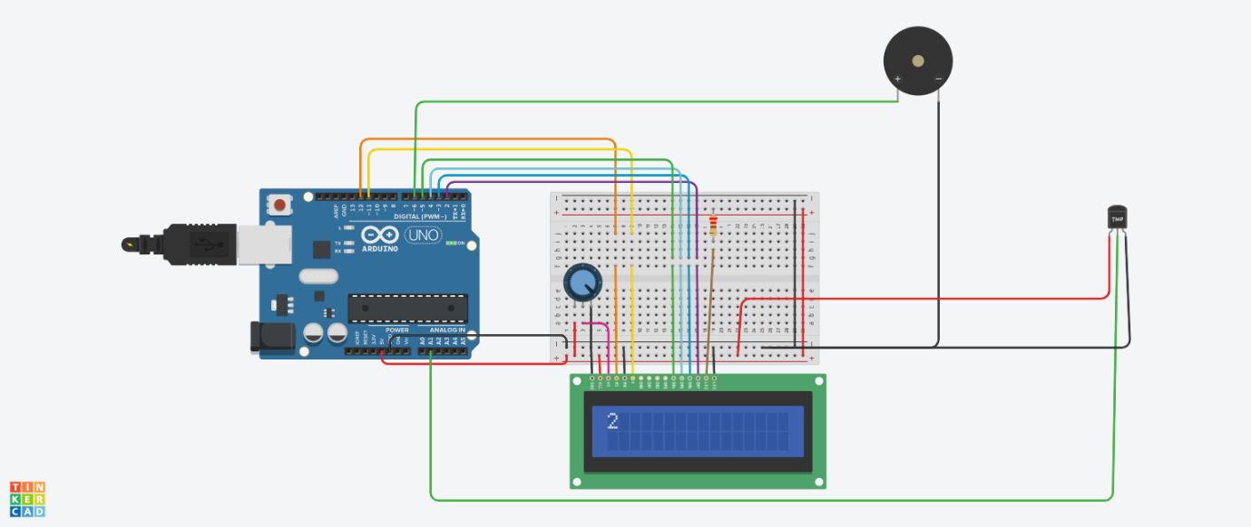

#include <LiquidCrystal.h>

LiquidCrystal lcd(12, 11, 5, 4, 3, 2);

float a;

void setup() {

lcd.begin(16, 2);

pinMode(6,OUTPUT);

}

void loop() {

a=analogRead(1);

a=a*0.0048828125;

a=(a-0.5)*100;

lcd.clear();

lcd.setCursor(0, 0);

lcd.print(a);

lcd.print("C");

if(a>60)

{

digitalWrite(6,HIGH);

}

else

digitalWrite(6,LOW);

}